Rajshahi University of Engineering & Technology


Department of Computer Science and Engineering

Course Code : CSE 3108
Course Title : Computer Architecture Sessional

Lab Report - 01

Name of the Experiment: Digital circuit simulation using Logisim.
Submission Date : 11-05-2024
Submitted By: Submitted To:

Eazdan Mostafa Rafin Utsha Das
Roll: 2003055 Lecturer
Section : A Dept. of CSE, RUET

Name of the Experiment: Digital circuit simulation using Logisim
Theory:
A full adder is a digital circuit that performs addition on three binary inputs and produces two outputs: the sum (S) and the carry (Cout). A full adder takes three inputs: A, B, and Cin (carry-in) and produces two outputs: S (sum) and Cout (carry-out).
A four-bit full adder circuit is constructed by cascading four full adders together. Each full adder takes two bits from the binary numbers to be added (A and B) and a carry-in (Cin) from the previous stage. The sum (S) output from each full adder forms one bit of the result, and the carry-out (Cout) is propagated to the next full adder as the carry-in (Cin). The carry-out from the last full adder represents the carry-out from the entire four-bit addition.The four-bit full adder circuit allows for the addition of two four-bit binary numbers, producing a four-bit sum and potentially an additional carry-out if the addition overflows beyond four bits.
Truth Table:
Full Adder Circuit:
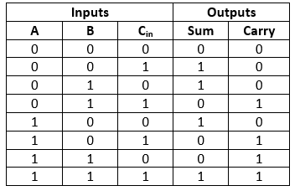

Four bits FA:
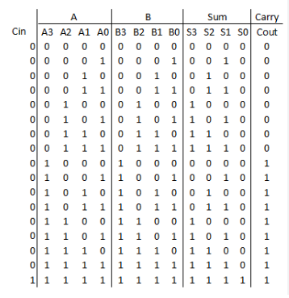

Output: 